Contributor: Cynthia Canejo

**Brecheret, Victor**

Born: December 15, 1894, Farnese, Italy; Died: December 17, 1955, São Paulo, Brazil

Victor Brecheret was a modernist sculptor with a unique style, which incorporated the grace of **Art Nouveau** and **Art Deco** design and the purity of the School of Paris. Working in São Paulo, one of the centers of the avant-garde during the earliest manifestations of modernism in Brazil, Brecheret participated in the ***Semana de Arte Moderna de 1922***(Week of Modern Art) organized by a group of modernists for the centennial celebration of Brazilian independence that took place in the Teatro Municipal de São Paulo between February 3 and 17, 1922. Brecheret became an important part of this intellectual group which included the painters **Anita Malfatti** and **Emiliano Di Cavalcanti**; the poet, Menotti del Picchia; and the writers, **Mario de Andrade and Oswald de Andrade**. Brecheret was inspired to simplify his sculptural forms while visiting the Parisian ateliers of two noted sculptors: the Romanian, **Constantin Brancusi**, and the Frenchman, **Aristide Maillol**. As a modernist working on public monuments, such as the *Monumento às Bandeiras* (*Monument to the Pioneers*), in the Ibirapuera Park, São Paulo, 1936-1956, Brecheret was able to unite his national tendencies with his international inclinations. In working with ideas from both Brazil and Europe, Brecheret assimilates national subject with international style while embracing a unique design. In choosing unusual poses or unconventional designs, he gives traditional themes a unique character. Adapting European style to Brazilian themes and forms, he creates a work decidedly his own.

Born Vittorio Breheret in Italy, Victor Brecheret had a twin sister Adalgisa (while his birth certificate cites the birthplace as São Paulo, his son Victor Brecheret Filho has verified that his father was born in Italy). When his mother died in 1900 and his father was unable to raise the two children, an aunt in São Paulo brought the twins to Brazil in 1904 when Victor was ten. Recognizing his talent, in 1913, his aunt and uncle paid for him to travel to Naples, Italy; before long, he was in Rome; he then returned to Brazil in1919. Brecheret received a government scholarship in 1921 to study in Paris where, in 1923, he was in contact with Brancusi.

Two of Brecheret’s early religious sculptures made in the 1920s, *Pietá* and *Ascensão (Ascension)*, show a unique interpretation of traditional themes through focusing on specific moments after Christ’s death. During this period, Brecheret was inspired by Art Nouveau works, in particular those of the Croatian sculptor, **Ivan Meštrovic**, who exhibited with the Secession Group in Vienna. Although generally in a pietá*,* the sorrowful Virgin is depicted seated holding the dead body of Christ in her lap, in Brecheret’s *Pietá* the depiction is made more emotional and dramatic by having the Virgin in an untraditional vertical pose; she is still standing grasping tightly the limp body of her son after he was taken down from the cross. The veil over her head reveals her face turned sadly towards his. In the *Ascension,* emphasis is on the spirit-like body of Christ slipping upward and away from the solid and grounded form of the Virgin Mary seated below. The abstraction and refinement of form in these pieces are an individual twist on the contemporary works of Brancusi. The traditional classical or academic figure and pose has been simplified; in his distinctive version, Brecheret has reduced the forms to basics using elongation and distortion of the bodies.

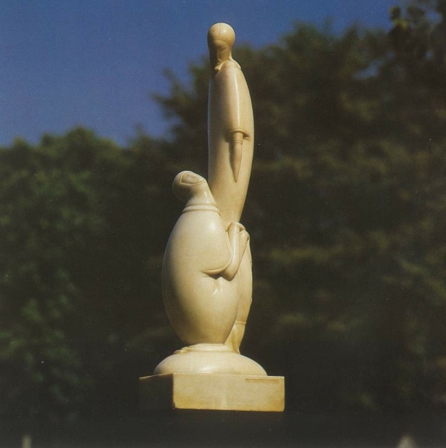

Brecheret, *Ascencão,* ca.1924

*Ascensão (Ascension),* from Pellegrini, *A Escultura Religiosa de Brecheret*, 35.

A change in style is apparent in Brecheret’s works of the 1930s. While sculptures such as *O Beijo (The Kiss),* 1933, still seems to owe something to Brancusi, they are more sensual and elegant and reflect emerging forms of Art Deco. The embrace of Brecheret’s couple could be compared with *The Kiss*, ca.1907-08, by the Austrian painter **Gustav Klimt** in the Viennese Art Nouveau style with its organic fluidity, sinuous curves, and flowery or vine-like decoration. In contrast, in Brecheret’s *The Kiss*, the two figures almost meld together and the more angular, streamlined, and sleek forms of Art Deco are introduced.

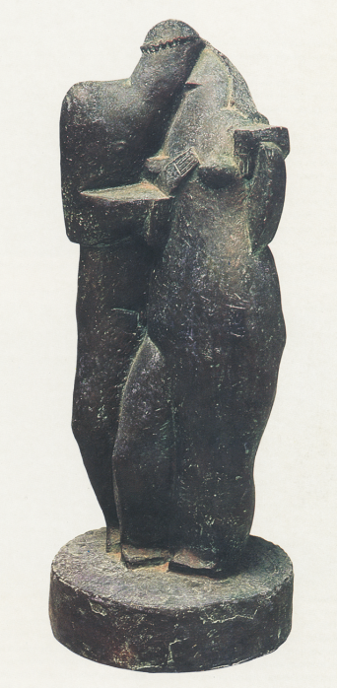

Brecheret, *Kiss,* 1933

http://www.nemirovsky.org.br/v2/index.php/victor-brecheret-2?start=1

Brecheret’s well-known public sculpture, *Monument to the Pioneers,* in the center of the roundabout at the entrance to Ibirapuera Park in São Paulo was originally commissioned by the state government in 1920 but delayed for numerous years. Finally, in 1936, the government approved and signed a contract. The work is a monumental homage to pioneer São Paulo explorers and expeditions who led the way into the backlands. A dramatic grouping of thirty-seven figures push in a forward motion showing strength and perseverance.

**Further reading:**

Alvarado, Daisy V. M. Peccinini de. *Brecheret: a linguagem das formas*. São Paulo: Instituto Victor Brecheret, 2004. (includes an English translation)

Lopez, Telê Ancona. “Mário de Andrade e Brecheret nos primórdios do modernismo.” *Revista USP,* São Paulo, n. 94, junho/julho/agosto (2012): 29-38.

Pellegrini, Sandra Brecheret. *Brecheret - 60 anos de notícia*. São Paulo: Companhia Melhoramentos de São Paulo, 2000.

Sandra Brecheret Pellegrini (coord.), *A Escultura Religiosa/Religious Sculpture de Brecheret,* São Paulo: Raízes Artes Gráficas, 2001.

IVB: Instituto Victor Brecheret (Institute Victor Brecheret), Victor Brecheret Filho (son of Victor Brecheret), President<http://www.brecheret.com.br>

Vida and Obra de (Life and Work of ) Victor Brecheret, Fundação (Foundation) Victor Brecheret, data provided by his daughter Sandra Brecheret Pellegrini <http://www.victor.brecheret.nom.br/>

**List of Works:**

Victor Brecheret, *Tocadora de Guitarra (Guitar Player),* 1923, bronze, 75x21x16cm

Victor Brecheret, *Ascencão (Ascension),* ca.1924, marble, 83x25cm

Victor Brecheret, *Pietà,* ca. 1926-27, granite or marble versions

Victor Brecheret, *O Beijo (The Kiss),* 1933, bronze, 33cm

Victor Brecheret, *Monumento às Bandeiras* (*Monument to the Pioneers*), Ibirapuera Park, São Paulo. 1936-56, 50x15x6m